W-16

12 PHYSICS ATAR

TEST 9 - STANDARD MODEL

NAME: MARK: 

1. What name is given to the modern quantum mechanical theory that describes the interaction of all matter at the fundamental level? [1 mark]

2. By referring to your knowledge of particle physics, explain what is meant by the term ***fermion***. [2 marks]

3. Identify two fermions that are different and describe how the properties of your chosen particles differ. [2 marks]

4. By referring to your knowledge of particle physics, explain what is meant by the term ***boson***. [2 marks]

5. Consider the Feynman diagram shown here.

(a) Explain the process being described by this Feynman diagram. [2 marks]

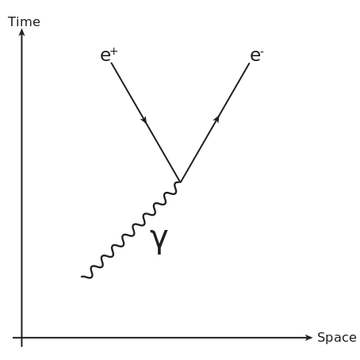

(b) If the matter/antimatter pair produced travelling with a velocity of 3.70 x 105 ms-1, calculate the frequency of the original boson. [4 marks]

6. Consider figure 1 and figure 2 shown below.

|  |  |
| --- | --- |
|  |  |
| **Figure 1** | **Figure 2** |

(a) Name the fundamental force that is being represented in these diagrams. [1 mark]

(b) Explain what process is being described by the Feynman diagrams shown as Figure 1 and Figure 2. [2 marks]

Figure 1

Figure 2

7. The Feynman diagram shown here represents a common nuclear physics process.

(a) Name the process represented here.[1 mark]

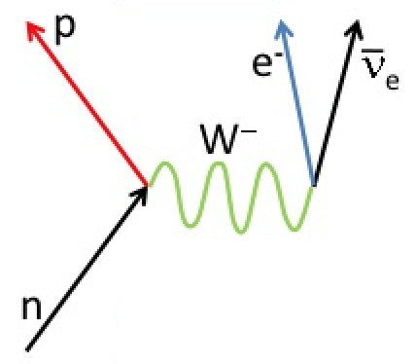

(b) Write the balanced equation to represent the process shown in the above Feynman diagram. [2 marks]

(c) Name the fundamental force that is being represented in the above diagram. [1 mark]

8. The following table shows some of the properties of the six flavours of quarks.

|  |  |  |  |  |
| --- | --- | --- | --- | --- |
| **Quark Flavour** | **Strangeness** | **Charm** | **Bottomness** | **Topness** |
| Up | 0 | 0 | 0 | 0 |
| Down | 0 | 0 | 0 | 0 |
| Strange | -1 | 0 | 0 | 0 |
| Charm | 0 | +1 | 0 | 0 |
| Bottom | 0 | 0 | -1 | 0 |
| Top | 0 | 0 | 0 | +1 |

(a) Complete the table shown below for the particles given. [4 marks]

|  |  |  |  |  |  |
| --- | --- | --- | --- | --- | --- |
| **Particle** | **Constituent particles** | **Formula** | **Baryon or Meson** | **Charge** | **Baryon number** |
| Antiproton | Anti-up, anti-up, anti-down |  |  |  |  |
| Kaon-minus | Anti-up, strange |  |  |  |  |
| D-plus-s | Charm, anti-strange |  |  |  |  |
| Upsilon | Bottom, anti-bottom |  |  |  |  |

(b) The four fundamental forces are: A. Electromagnetic force

B. Weak nuclear force

C. Strong nuclear force

D. Gravitational force

(i) Which of these forces mediate an interaction with the particles shown in the table of part (a)? [1 mark]

a. All of the forces shown.

b. A, B & C only.

c. B, C & D only.

d. A, C & D only.

ii. Will any of the particles shown in the table above interact with the Higgs boson? Explain your answer. [3 marks]

9. The nearest star to the Sun (and thus the star with the largest parallax) is Proxima Centauri and has a parallax of 0.7687 arcsec.

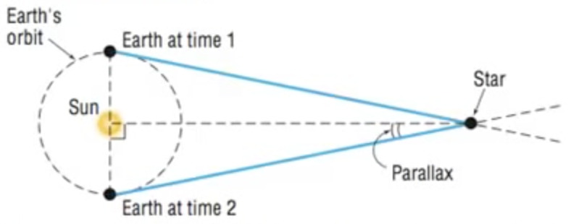

Calculate the distance to Proxima Centauri:

(a) in parsecs. [2 marks]

(b) in light years. [2 marks]

(c) in meters. [2 marks]

10. State two pieces of evidence that support the Big Bang Theory and the expansion of the Universe. [2 marks]

11. Explain what is meant by the term ***redshift***. [3 marks]

12. The spectral analysis given below shows the observed absorption spectra of hydrogen for the following cases:

(i) not moving.

(ii) moving away from you at 3,000 kms-1.

(iii) moving away from you at 30,000 kms-1.

|  |  |
| --- | --- |
| i) |  |
| ii) |
| iii) |

(a) ***Estimate*** the redshift of object (ii) with respect to the stationary observer (i). Show all estimates and working. [4 marks]

(b) Show that the recessional speed of object (ii) is around 3000 kms-1 with respect to observer (i). Show all working. [3 marks]

13. Hubble’s Law demonstrates the direct linear relationship between distance to interstellar objects and their recessional velocities.

(a) Show, by algebraic manipulation, that Hubble’s Law can be used to determine the age of the Universe. [3 marks]

(b) The most up-to-date and current best direct measurement of the Hubble constant is 73.8 km/sec/Mpc. Use this to calculate the age of the universe in years. [4 marks]

**Data**

1.00 pc = 3.26 light years

**Fundamental particles**

